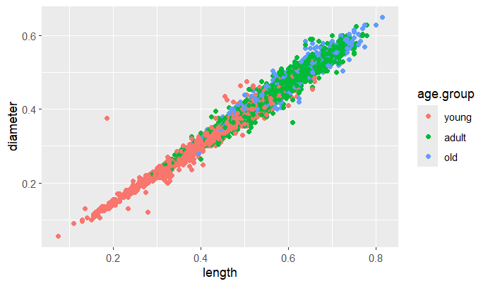

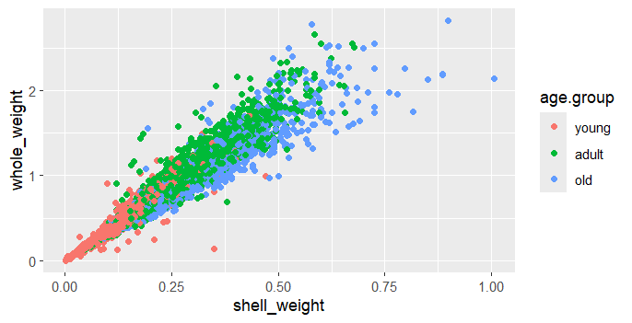

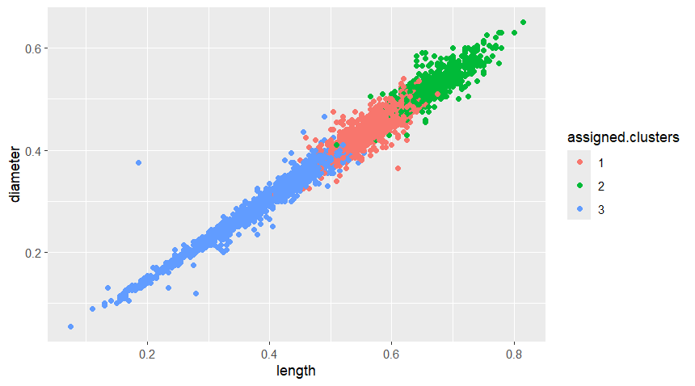

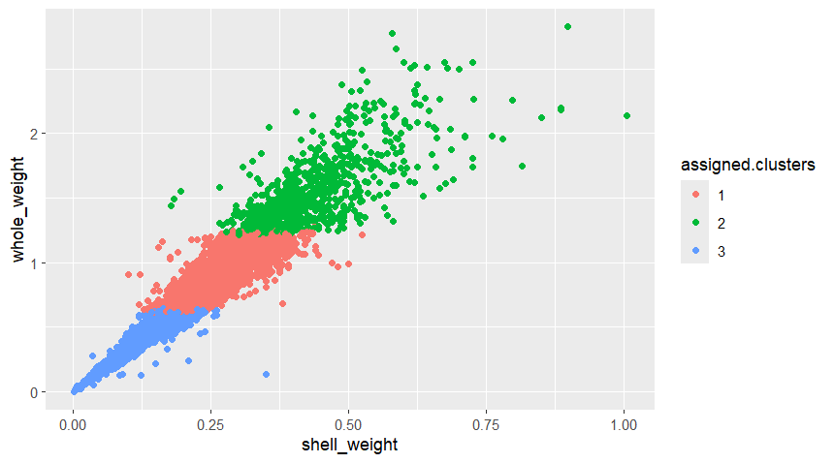

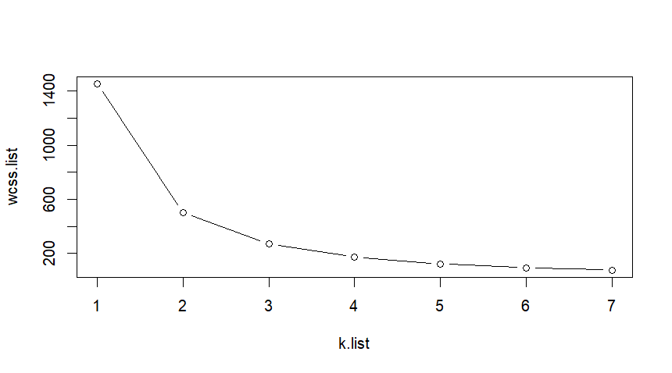

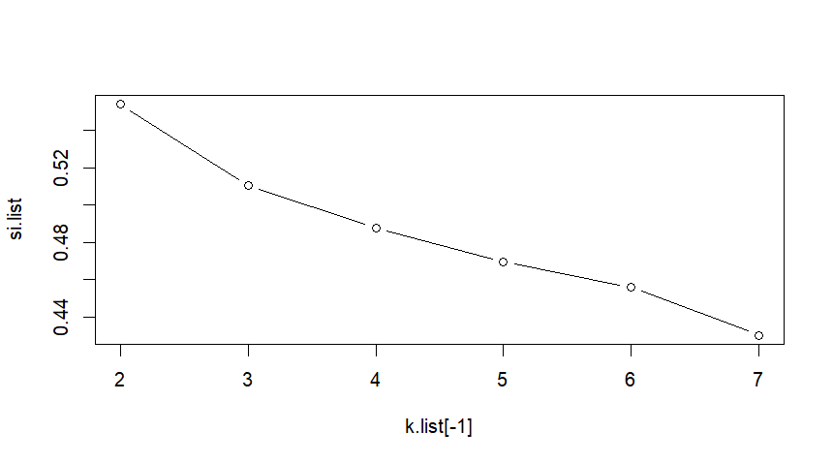

wcss.list

[1] 1449.60829 502.99259 271.32434 173.15648 124.10876 95.65256 78.24224

diff(wcss.list)

[1] -946.61570 -231.66825 -98.16786 -49.04771 -28.45620 -17.41031

diff(diff(wcss.list))

[1] 714.94745 133.50039 49.12015 20.59151 11.04589